ADRIAN TURION |  | Avenue de Sainte-Clotilde 9  1205 Geneva, Switzerland | 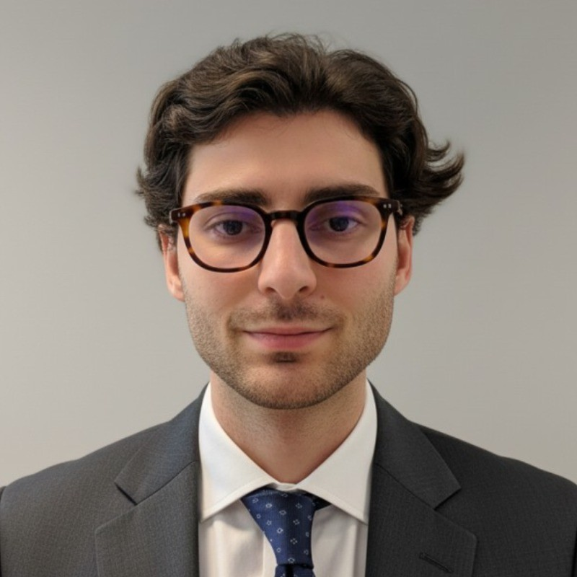
turionadrian@gmail.com | Swiss | 10.11.2000 |  | +41 77 262 37 96
INTRODUCTION
Due diligence-focused MSc Finance candidate with hands-on experience building LBO, DCF, and comparable models across 10+ transactions. Strong foundation in valuation and portfolio analysis developed in a lean deal team environment. Entrepreneurial mindset demonstrated by founding an AI-powered tool now used by 3 advisory firms, reducing research time by 90%.
WORK EXPERIENCE
Auraïa Capital Advisory – Small & Mid Cap Cross-border M&A Boutique  Mergers & Acquisitions Analyst (Converted internship into full-time position) |  | Geneva, Switzerland  Aug 2024 – Current
- End-to-end transaction exposure in a lean 3-person deal team, managing projects from initial due diligence through valuation, negotiations, and closing across 10+ live mandates spanning healthcare, tech, and life sciences sectors
- Built detailed financial models (LBO, DCF, trading comps, precedent transactions) and prepared client presentations for Board meetings, developing expertise in valuation methodologies and fund accounting principles
- Performed quality of earnings analysis and comparable company analysis using both public and private data to identify value drivers and support transaction pricing for deals ranging from EUR 5M to EUR 50M

RC Group – Currently under LBO with Crédit Mutuel Equity  Mergers & Acquisitions Intern |  | Paris, France  Feb 2024 – Aug 2024
- Conducted financial and operational due diligence on acquisition targets (EUR 10M-30M revenues) for a company under LBO with Crédit Mutuel Equity, analyzing synergies, market positioning, and post-acquisition integration opportunities across 3 potential targets

Europ Assistance – Subsidiary of Generali Insurance  Financial Analyst Intern |  | Geneva, Switzerland  Apr 2023 – Aug 2023
- Built automated financial dashboards in Excel and PowerBI to monitor KPIs and performed monthly P&L variance analysis for Europ Assistance (CHF 50M+ revenues, Generali subsidiary), supporting quarterly forecasting and annual budget planning for 5 business units

LEADERSHIP
- Presented predictive analytics model to McKinsey consultants and Keyrock management as Top 5 finalist, showcasing CHF 200K annual revenue potential through black swan event forecasting
- Founded Screeny.ai, an AI tool identifying strategic acquirers for M&A boutiques, reducing buyer search from 10+ hours to 20 minutes; adopted by 3 advisory firms with 90% time savings
- Manage diversified investment portfolio using options strategies (Cash Secured Puts, Covered Calls), achieving 8% annualized returns through disciplined risk management and theta decay
EDUCATION
HEC Lausanne  Master of Science in Finance |  | Lausanne, Switzerland  2021 – 2024
- Cumulative GPA: 5.2/6.0 (Top 15% of the class cohort)
- Exchange programs at Waseda University (Tokyo, Japan) and Maastricht University (Maastricht, Netherlands)
- Relevant Coursework: Valuation, Corporate Governance and M&A, Quantitative Asset and Risk Management
- Thesis Topic: Synergies Analysis of the Merger between American Airlines & US Airways

Bachelor of Science in Management |  | 2018 – 2021
- Cumulative GPA: 4.7/6.0

Scientific Baccalaureate with Highest Honors (16.6/20) |  | Aix-en-Provence, France
ADDITIONAL INFORMATION
Languages:  Computer:  Interests:  References: | French (Native, C2), Spanish (Native, C2), English (Fluent, C1), German (Business proficient, B2-C1)  Financial Modeling | Valuation | Due Diligence | M&A Analysis | Excel & PowerBI  Geopolitics, Badminton (Provence regional finalist), Gym, Real use cases of Artificial Intelligence  Guillaume Arnaldez – Ex-Director at Auraïa Capital Advisory, guillaume.arnaldez@auraia.ch  Sacha Caravatti – CFO at Europ Assistance Switzerland, scaravatti@europ-assistance.ch

